
Company
Logotype

Cone Beam Computed Tomography- Report



Porur Dental X-rays & CBCT

Patient Name : Mr. Venkatraman | Date of Report : 24.07.2024
Age/ Gender : 42 years/ Male | Region of Interest : CBCT Sectional Maxilla
Referring doctor: Dr. Suchitra Mohan | Indication : Assessment of 16
Clinical Notes: Nil
PATIENT INFORMATION

CBCT- Sectional Maxilla provided
CBCT – IMAGE DETAILS

RADIOGRAPHIC INTERPRETATION

- Presence of hyperdense crown structure in 16, with presence of restorative material with the root canal extending upto the apical third of roots is evident.
- The maxillary alveolar ridge is present with normal trabecular pattern.
- The right maxillary sinus is present with mucosal thickening in relation to the floor, medial wall and the lateral wall of the sinus.

RADIOGRAPHIC IMPRESSION

- Root canal treated tooth with crown : 16
- Maxillary sinusitis: right side.

Kindly correlate with clinical findings


IMAGES FOR REFERENCE

RECONSTRUCTED PANORAMIC VIEW

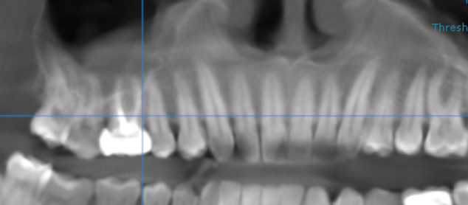

3-DIMENSIONAL VIEW

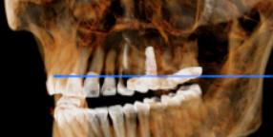

CROSS SECTIONAL VIEW

16 region | 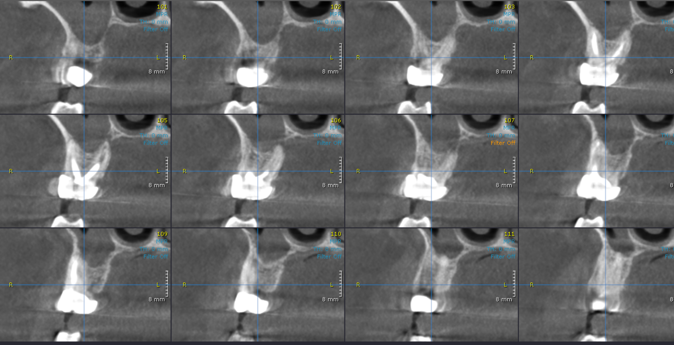

**** End of report ****

